WORKSHOP # 31

University of the Armed Forces ESPE

Computer Science Department

Software Engineering



ADVANCED WEB DEVELOPMENT

NRC 2296

03/05/2025

| Project assets | | |
| --- | --- | --- |
| Asset/artifact | Observations | Evaluation/10 |
| 0- Github | x |  |
| 1- Letters(3) | x |  |
| 2- Server(URIs 9) | x |  |
| 3- Client(9 Screens) | 1 pto/page + 1, 2:00 there are only 6 pages |  |
| 4- Test the server down | x |  |
| 5- Input Validation | x |  |
| 6- Navigability | x |  |
| 7- Documentation -> SRS, Class Diagram, Mockups | x |  |
| 8- Login OAuth+Session | x |  |
| 9- CRUD Back-end | x |  |
| 10- CRUD Front-end | x |  |
| TOTAL |  | /100 → /3 |

EVIDENCE

0- GitHub

1- Letters(3)

2- Server(URIs 9)

3- Client(9 Screens)

4- Test the server down

5- Input Validation

6- Navigability

7- Documentation -> SRS, Class Diagram, Mockups

8- Login OAuth+Session

9- CRUD Operations Back-end

10- CRUD Operations Front-end

_______________________________________________________________________

**Team 1**

Leader: Kleber Chavez

TName: Bakery Devs

Project: **Panaderia Ruminiahui**

**GitHub:** <https://github.com/kechavez07/Panes-de-la-Rumi-ahui.git>

**DB:** Render-> usar pgadmin

para configurar la base de datos escribir al 0963366387 servicio técnico personalizado

uirs en la nube: https://api-panes-ruminahui.onrender.com

Client URL (home page): <https://panes-ruminahui.onrender.com>

Credential:

Server name: panes_de_la_ruminahui

Host: dpg-cv448ftds78s73e3m7i0-a

Database: panes_de_la_ruminahui_qd9b

Username: panes_de_la_ruminahui_user

Password: fxZVwetG2w6gIUBfYFfg37q16fbGLCac

**Inspector Team 2:** ScrumMasters **Leader:** Isaac Escobar

1. Asmal Kevin
2. Casignia Diego
3. Chavez Kleber

Note: 73/100

| Project assets Team 1 | | |
| --- | --- | --- |
| Asset/artifact | Observations | Evaluation/10 |
| 0- Github |  |  |
| 1- Letters(3) | They are have all letters of the customer | 10 |
| 2- Server(URIs 9) | Don’t have rule of business | 5 |
| 3- Client(9 Screens) | Don’t function very well to the enter the page | 9 |
| 4- Test the server down | Don’t function very well | 5 |
| 5- Input Validation | Don’t function | 0 |
| 6- Navigability | Function of the page but the login no function very well | 9 |
| 7- Documentation -> SRS, Class Diagram, Mockups | Don’t have Category -1  Don’t have one class | 8 |
| 8- Login OAuth+Session | No function de login | 0 |
| 9- CRUD Back-end | No validate name -1 | 8 |
| 10- CRUD Front-end | All are good | 10 |
| TOTAL | 73 | /100 → 2.19 /3 |

GitHub

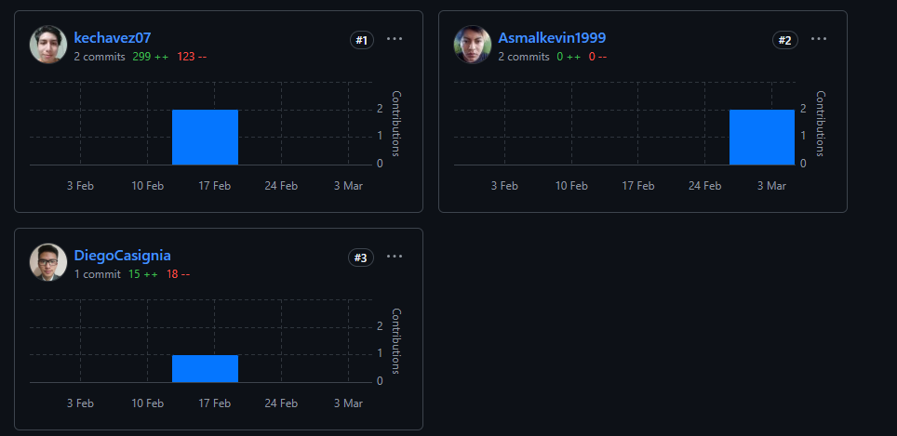

Letters:

Client:

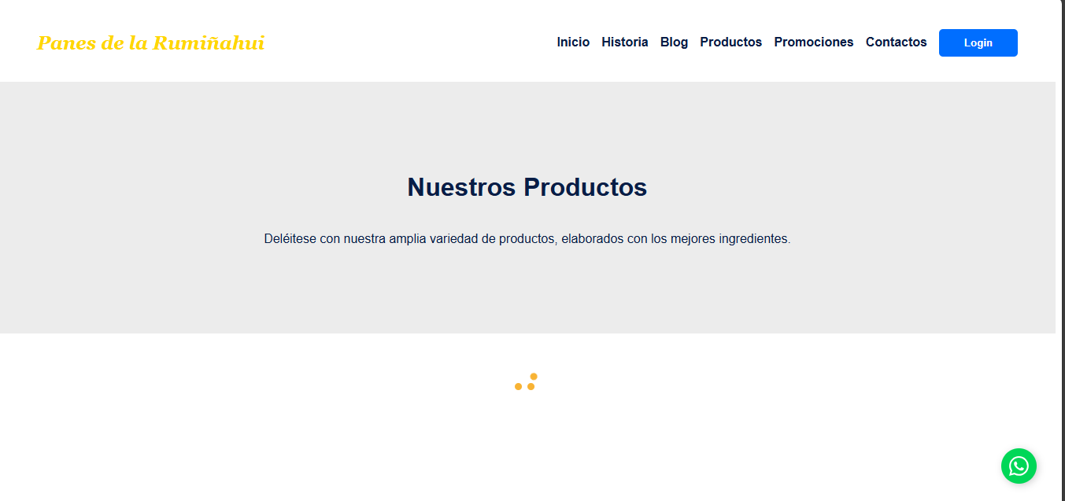

_______________________________________________________________________

**Team 2**

**Leader:** Isaac Escobar.

**TName:** Bakery Devs.

**Project:** Mahanaym System.

**GitHub:**

**Document:**<https://github.com/YeshuaChiliquingaAmaya/AWD22962024ScrumMasters.git>

**Repository:** <https://github.com/YeshuaChiliquingaAmaya/MERN-Mahanaym-Management-System/tree/main>

**Backend:** <https://mahanaym-backend.onrender.com/>

**FrontEnd:** <https://mern-mahanaym-management-system.vercel.app/>

**Link URL’s:** <https://docs.google.com/document/d/1AmjHwoRH_3-Jrw85VtGXNkgE0rwhkpT5zXK-66nFCVo/edit?usp=sharing>

**Credenciales:**

**Student:**

idStudent:67bb547fac8ff50d2db7d50e

**Roll Number:** 3

**Username:** Juanito Alimaña

**Password:**123456

**Teacher:**

idTeacher:67bb5506ac8ff50d2db7d555

**Username:** [lascano@espe.edu.ec](mailto:lascano@espe.edu.ec)

**Password:** 123456

**Admin:**

idAdmin:67baaf4671bba6c0e4273dfd

**Username:** [juan.perez@example.com](mailto:juan.perez@example.com)

**Password:** 123456

DB: Render-> usar pgadmin

para configurar la base de datos escribir al 0963366387 servicio técnico personalizado

uirs en la nube: https://api-panes-ruminahui.onrender.com

Client URL (home page): <https://panes-ruminahui.onrender.com>

**Inspector Team 3:** BugSlayers **Leader:** Josue Guallichico

1. Chiliquinga Yeshua
2. Cuadrado Alejandro
3. Escobar Isaac

| Project assets | | |
| --- | --- | --- |
| Asset/artifact | Observations | Evaluation/10 |
| 0- Github |  |  |
| 1- Letters(3) | the letter are visible an had a good look | 8 |
| 2- Server(URIs 9) | URIS are not single purpose | 9 |
| 3- Client(9 Screens) | the UI are intuitive | 10 |
| 4- Test the server down | The home page is down | 10 |
| 5- Input Validation | Some forms is not validated | 5 |
| 6- Navigability | The navegability is good | 5 |
| 7- Documentation -> SRS, Class Diagram, Mockups | there are some inconsistencies between the page and the documentation | 8 |
| 8- Login OAuth+Session | Login Local | 9 |
| 9- CRUD Back-end | some inputs is not validated | 7.5 |
| 10- CRUD Front-end | some inputs is not validated | 6.5 |
| TOTAL |  | 78/100 → /3 |

Github

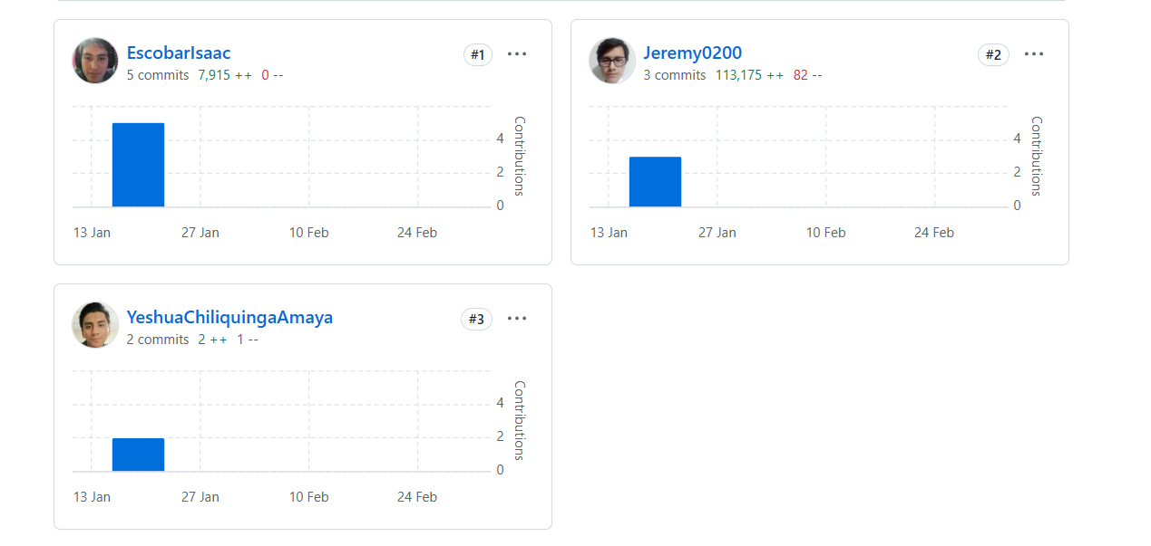

_______________________________________________________________________

Team 3

Leader: Josue Gualichico

TName:The bug slayer

Project:CEPD

GitHub: <https://github.com/kiboki1234/AWD22962024TheBugSlayer.git>

DB:mongodb+srv://kiboki:kiboki@[cluster0.gdvvk58.mongodb.net/?retryWrites=true&w=majority&appName=Cluster0](http://cluster0.gdvvk58.mongodb.net/?retryWrites=true&w=majority&appName=Cluster0)

Client URL (home page): <https://awd-22962024-the-bug-slayer.vercel.app/>

Credenciales para ingresar al sistema: [pedro@example.com](mailto:pedro@example.com)  
Contraseña:123456

Inspector Team 4:Alpha Team Leader: Josue Marin

1. Espin Andres
2. Gualichico Josue
3. Jaya Carlos

| Project assets | | |
| --- | --- | --- |
| Asset/artifact | Observations | Evaluation/10 |
| 0- Github |  |  |
| 1- Letters(3) |  | 0 |
| 2- Server(URIs 9) | ​​There are not 9 URIs | 6/10 |
| 3- Client(9 transactional pages ) | There are only 6 pages | 7/10 |
| 4- Test the server down |  | 10/10 |
| 5- Input Validation | validations number telephone | 8/10 |
| 6- Navigability | improve navigability | 7/10 |
| 7- Documentation -> SRS, Class Diagram, Mockups | SRS: requirements of system  class Diagram: 10 class an 10 database  Mockups: 0 | 7 |
| 8- Login OAuth+Session | login local: 4 session: 5 | 9/10 |
| 9- CRUD Back-end |  | 10/10 |
| 10- CRUD Front-end | delete don’t found | 7/10 |
| TOTAL |  | 71/100 → /3 |

0- Github

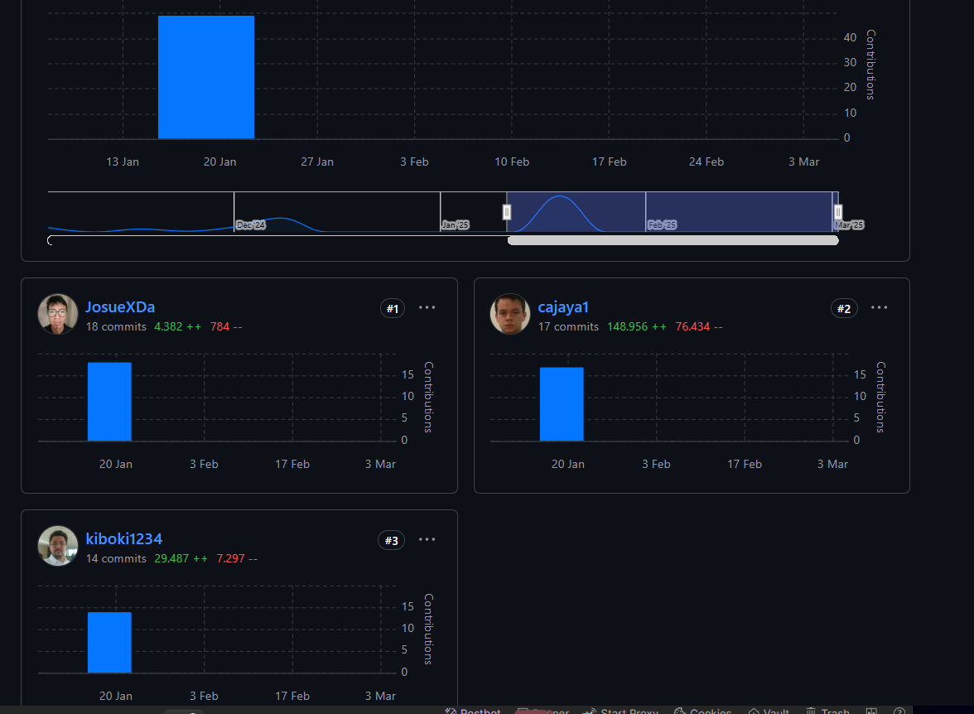

1- Letters(3)

2- Server(URIs 9)

3- Client(9 Screens)

6/9 +1 = 7

4- Test the server down

5- Input Validation

6- Navigability

7- Documentation -> SRS, Class Diagram, Mockups

8- Login OAuth+Session

9- CRUD Operations Back-end

10- CRUD Operations Front-end

_______________________________________________________________________

Team 4

Leader: Josue Marin

TName: Alpha Team

Project: Hollister Cente

GitHub: <https://github.com/marinjosue/AWD22962024AlphaTeam>

DB: <https://railway.com/invite/CZFvf0k8cw4>

Client URL:[Mi Página Principal](https://holistic-front.vercel.app/)

Credenciales para ingresar al sistema: 1754921755

Contraseña: 123

Inspector Team 5:The Three Musketeers Leader: José Proaño

1. Lugmaña Matias
2. Marin Josue
3. Orrico Camilo

| Project assets | | |
| --- | --- | --- |
| Asset/artifact | Observations | Evaluation/10 |
| 0- Github |  |  |
| 1- Letters(3) | All 3 letters delivered | 10 |
| 2- Server(URIs 9) | Only 3 Business Rules found | 4 |
| 3- Client(9 Screens) | One transactional page missing | 9 |
| 4- Test the server down | Client Page doesn't show data when server is down | 10 |
| 5- Input Validation | Only has some input validations | 3 |
| 6- Navigability | Login screen does not allow to go back | 8 |
| 7- Documentation -> SRS, Class Diagram, Mockups | -Five tables are missing from the database:   1. Authentication 2. Administrator 3. Schedule 4. Enrollment 5. Multimedia Content   -All mockups are present on the webpage  -One Requirement missing:   1. Payment of courses | 5 |
| 8- Login OAuth+Session | Login and Sessions working correctly | 15 |
| 9- CRUD Back-end |  | 10 |
| 10- CRUD Front-end |  | 10 |
| TOTAL |  | 84/100 → /3 |

0.- Github

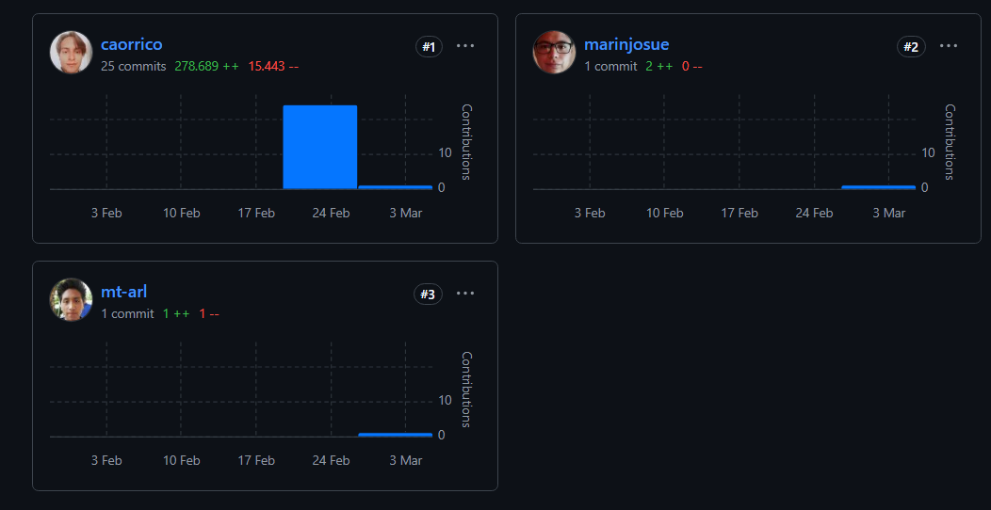

1.- Letters (3) 10

2- Server(URIs 9) 4

3- Client(9 Screens) 9

4- Test the server down 10

5- Input Validation 4

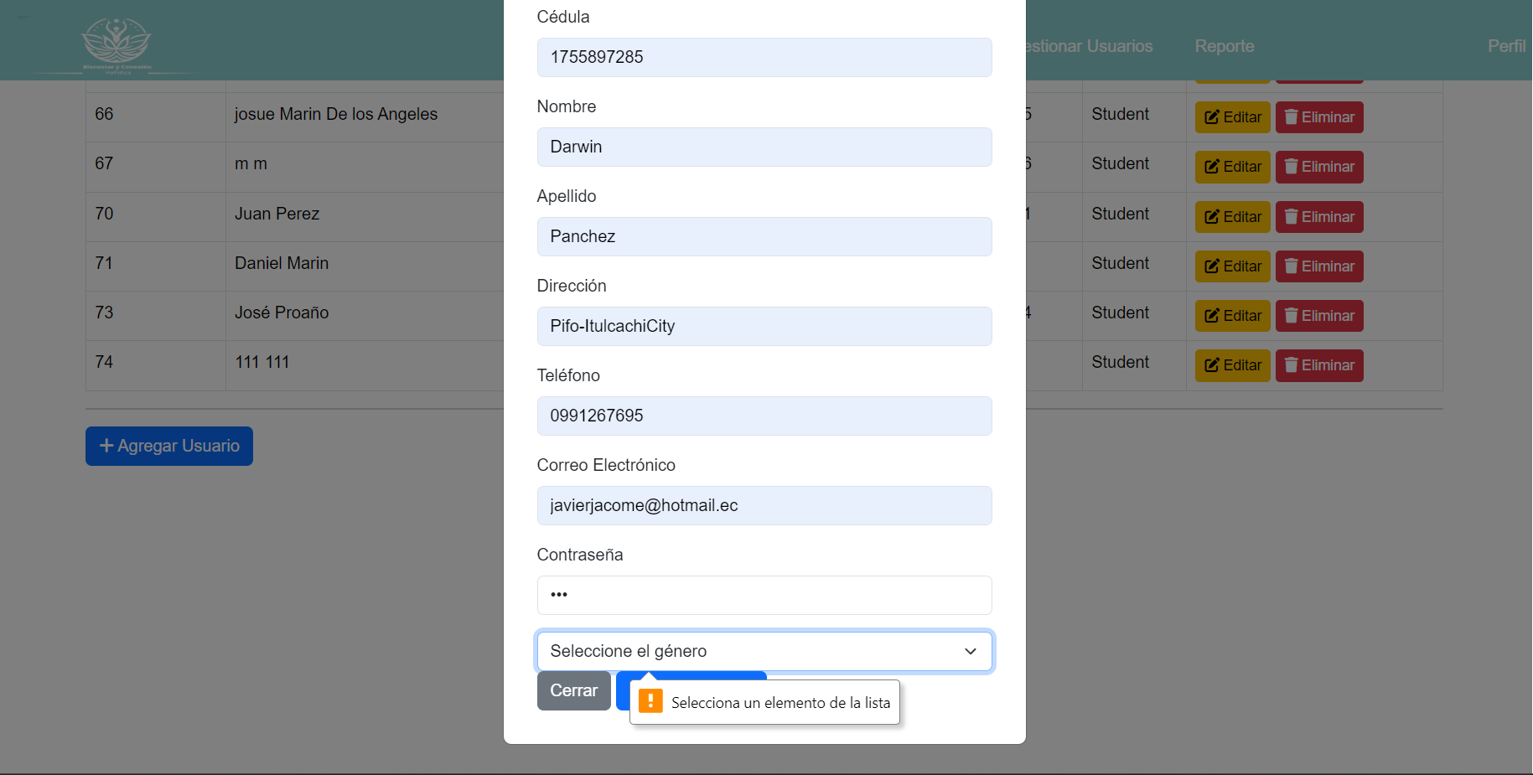

6- Navigability 10

7- Documentation -> SRS, Class Diagram, Mockups 5

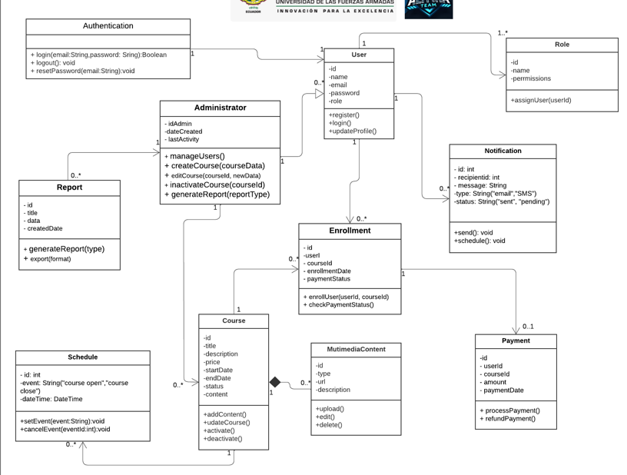

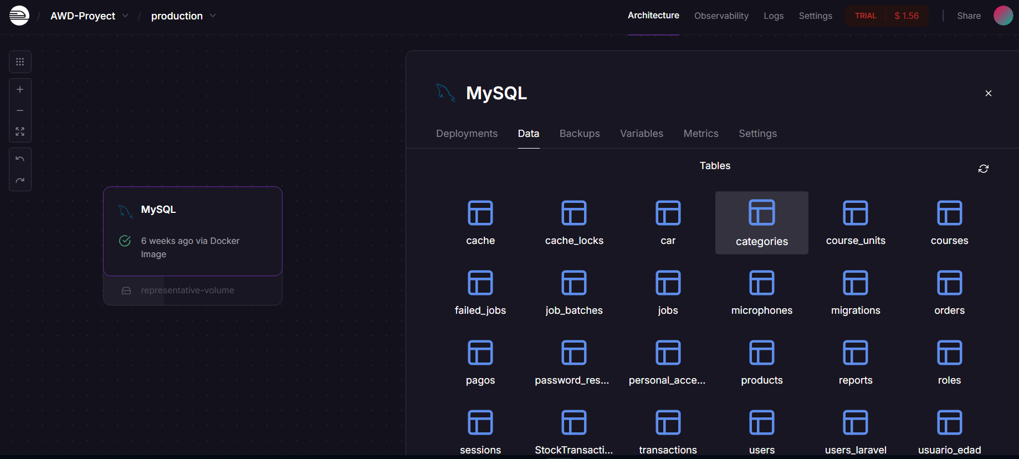

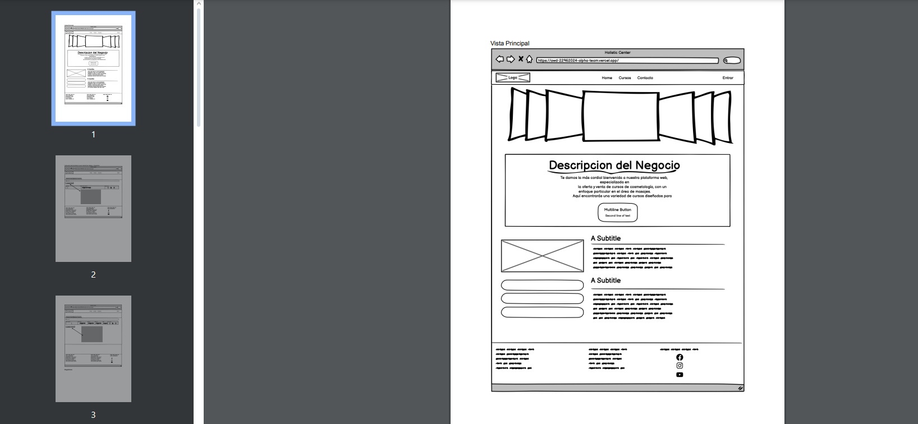

8- Login OAuth+Session 15

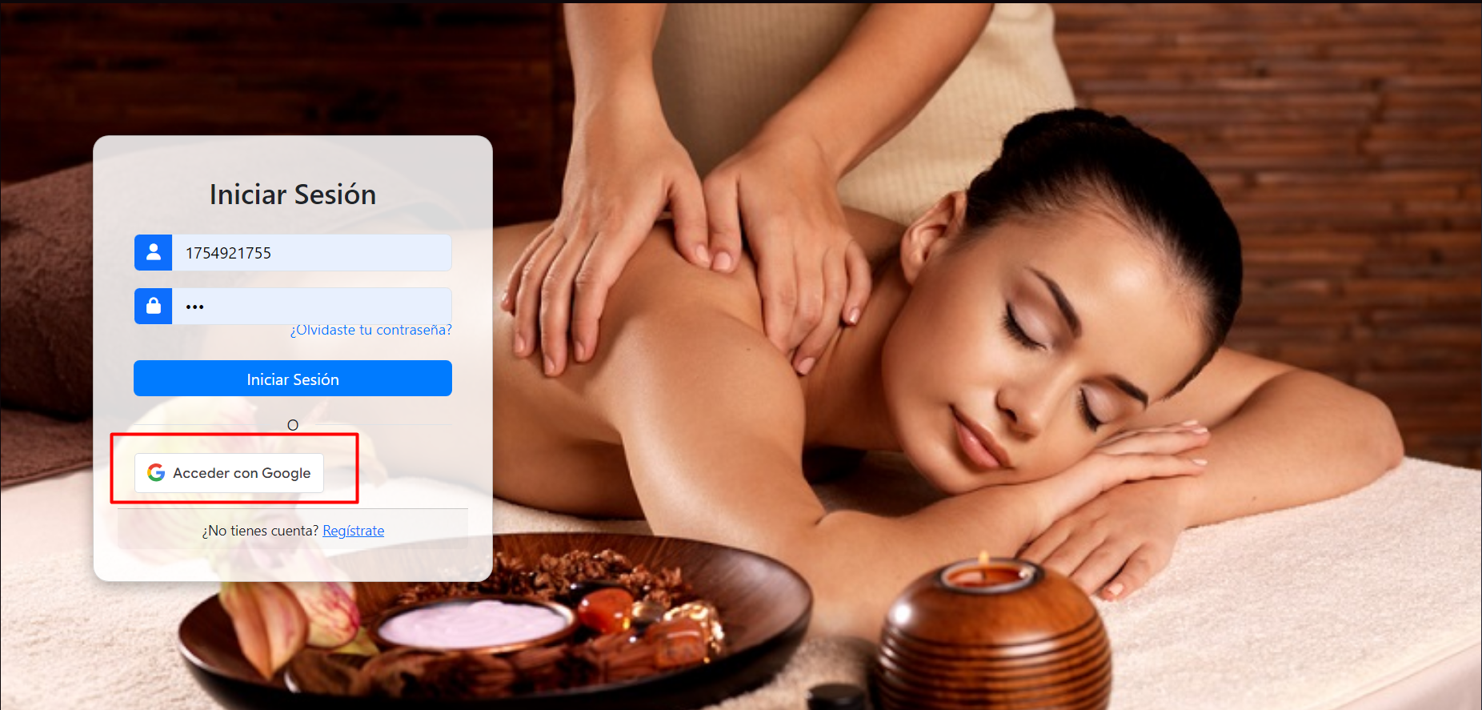

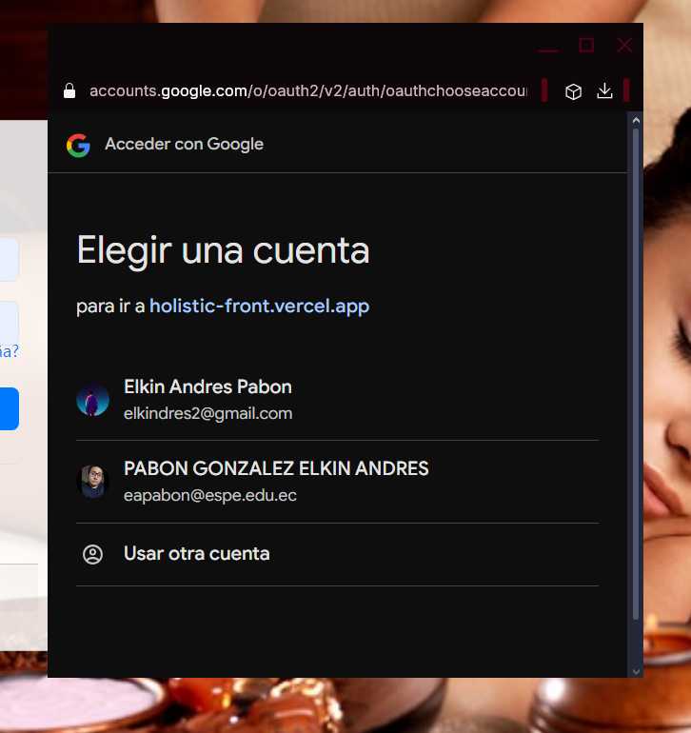

9- CRUD Operations Back-end (10)

10- CRUD Operations Front-end (10)

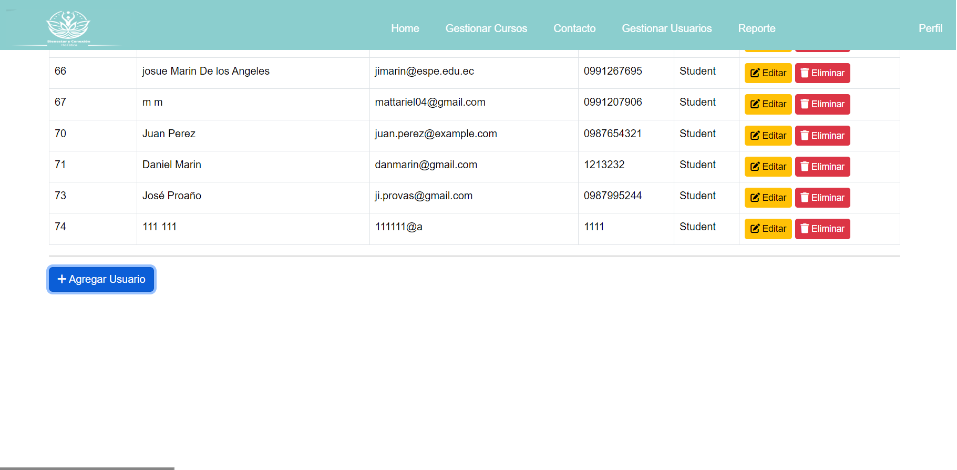

_______________________________________________________________________

Team 5

Leader: José Proaño

TName: The Three Musketeers

Project: Madecor: Inventory and Sales System

GitHub: <https://github.com/JoseProano/AWD22962024Team5.git>

DB: <https://railway.com/invite/6lA_ZenW1Gl>

Client URL (home page): <https://madecor-frontend.vercel.app>

Inspector Team :6 HTMLHeroes | Leader: Jose Sanmartín

1. Pabon Elkin
2. Darwin Panchez
3. Proaño Jose

| Project assets | | |
| --- | --- | --- |
| Asset/artifact | Observations | Evaluation/10 |
| 0- Github |  |  |
| 1- Letters(3) | Late | 5 |
| 2- Server(URIs 9) | There are missing some URI’s | 7 |
| 3- Client(9 Screens) | The validations sometimes doesn’t allow us register data | 8 |
| 4- Test the server down | Great | 10 |
| 5- Input Validation | Great | 10 |
| 6- Navigability | Great | 10 |
| 7- Documentation -> SRS, Class Diagram, Mockups | Great is all clear  Great all mockups | 10 |
| 8- Login OAuth+Session | All great | 15 |
| 9- CRUD Back-end | No POST of Products | 6 |
| 10- CRUD Front-end | No Post of Products | 6 |
| TOTAL |  | 85/100 → /3 |

0- Github

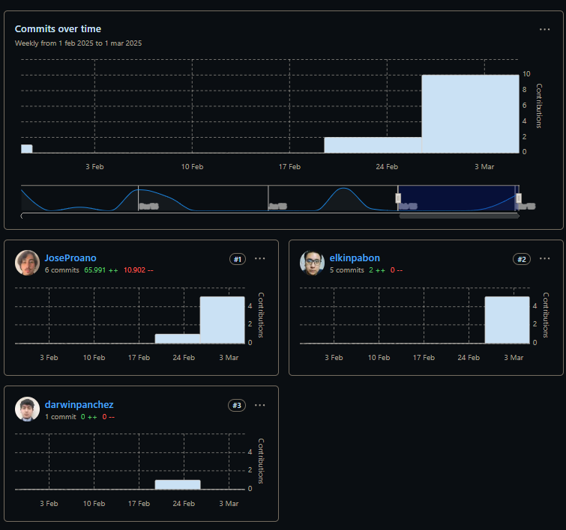

1- Letters(3)

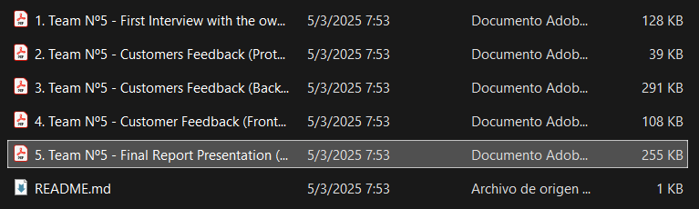

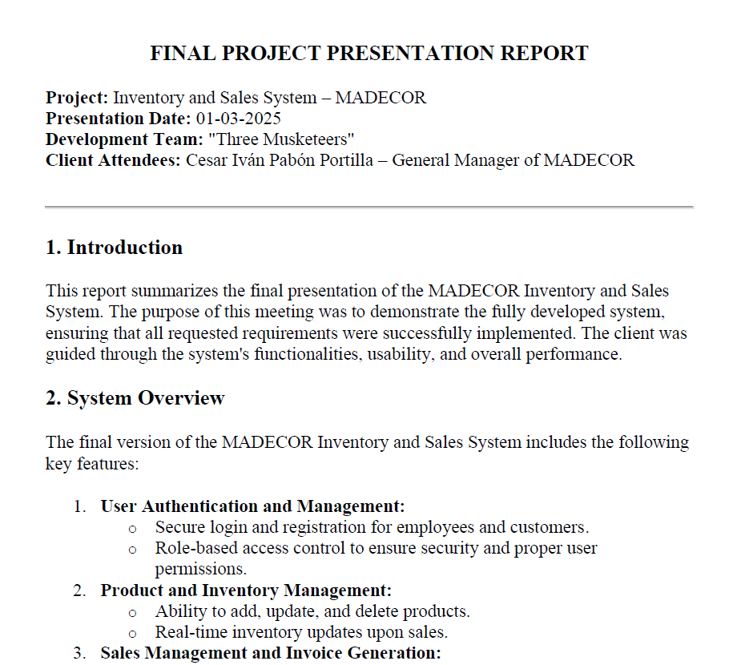

2- Server(URIs 9)

/login

3- Client(9 Screens)

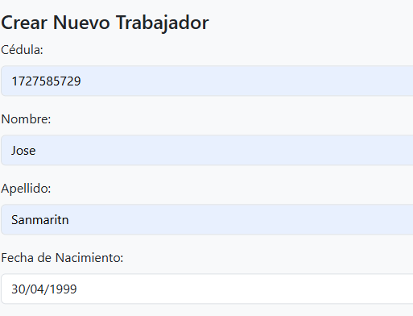

4- Test the server down

5- Input Validation

6- Navigability

7- Documentation -> SRS, Class Diagram, Mockups

8- Login OAuth+Session

9- CRUD Operations Back-end

10- CRUD Operations Front-end

___________________________________________________________________

Team 6

Leader: Jose Sanmartín

TName: HTMLHeroes

Project: Natulove Store

GitHub: <https://github.com/SanmartinJose/AWD22962024HTMLHeroes>

DB: Render-> <https://console.clever-cloud.com/users/me/addons/addon_e29b6744-5f26-4efd-beac-19a4daff6b8e>

Client URL <http://natulovesotre.free.nf/?i=1>

Inspector Team 2:HTMLHeroes Leader:

1. Salcedo Micaela
2. Sanmartin Jose
3. Suarez Matias
4. Villaroel Justin

| Project assets | | |
| --- | --- | --- |
| Asset/artifact | Observations | Evaluation/10 |
| 0- Github | x |  |
| 1- Letters(3) | x | 10 |
| 2- Server(URIs 9) | x | 9 |
| 3- Client(9 Screens) | 1 pto/page + 1, 2:00 there are only 6 pages | 8 |
| 4- Test the server down | x | 3 |
| 5- Input Validation | x | 7 |
| 6- Navigability | x | 9 |
| 7- Documentation -> SRS, Class Diagram, Mockups | x | 10 |
| 8- Login OAuth+Session | x | 9 |
| 9- CRUD Back-end | x | 7 |
| 10- CRUD Front-end | x | 8 |
| TOTAL |  | 80/100 → /3 |

validaciones 